

STI 2D, transversal English
The power of the water
A: Introduction
- Copy the title of the document. Make sure that you know how to pronounce it, so listen carefully…

- Figures (quantities) are given. Which ones? fill in the blanks or choose the right word

cubic meters of water past here at about km/h. that’s water to about Olympic swimming pools

- Choose or find the right word:

‘Standing here you can actually the of the water. that is what have been to do for over years in ‘

- Give the definition of electricity using the following words (which have been jumbled up!!!!!): you will add the necessary elements (articles, prepositions, relatives or others ….)to make proper sentences

Energy essence water factory electrons convert commonly electricity falling flow

B. Detailed comprehension

- What do most hydroelectric stations use?
- The water around a natural of a river, for ex: a or
- Or a is built across the to the water to the needed to create a

- Pronunciation: find out the right sound for the elements underlined: put the words in the right column
Fill feel designed divert built rise raise provide driving hydroelectric station

ei (cake) | ai (bye) | i (fish) | i: (sheep)

C. Animation
- Find out the elements to describe the photo (cross section of a hydroelectric station)

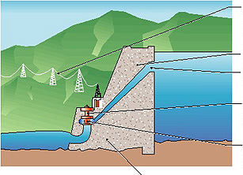

- Find out the VERBS necessary to describe the operations and a few other words which you must have selected for the cross section above

- Water at the higher level, is in the fore bay.
- It through the into a called the which
- it down to a at the lower water level.
- The water pressure as it down the
- and it is this pressure and flow that the that is to the generator.
- Inside the generator is the which is by the
- Large electro are to the located within of carpet wires called the
- As the generator the , a flow of electrons is in the of the
- This produces electricity that can be up in voltage through the station and across

- Write down the conclusion

- The falling water having served its purpose the generating station to the tailrace where it joins the main stream of the river to the cycle of creating for

